WP4 GNSS P-controller

1. **Description of the sensor**

The GNSS Leica Viva GS 15 is used to determine the position of the moving model vehicle, where the sensor is installed on the model and receives satellite signals during the test drive.

The global coordinates of the model are obtained directly from the GNSS receiver at discrete time stamps. The accuracy of the measurement is about 8 mm + 1 ppm for horizontal coordinates and about 15 mm + 1 ppm for vertical coordinate using RTK mode (source: <https://leica-geosystems.com>).

**Pros:**

* Fully independent code and phase measurements of all frequencies.
* The sensor can give exact position with greater precision and reliability due to the multi-available satellites.

**Cons:**

* Time for initialization are dependent upon various factors including number of satellites, observation time, atmospheric conditions, multipath etc.
* Vertical accuracy is less than the horizontal one.
* Using the phase observation could have some problems like: unknowns ambiguity for each satellite or cycle slips at tracking (loss of ambiguities), these problems can be solved by:
* using long observations time
* using of more than 4 satellites
* using of linear combination of L1 and L2

Table 1 Technical description of the Sensor (source: https://leica-geosystems.com)

|  |  |  |  |
| --- | --- | --- | --- |
| **Sensor name** | | | **Leica Viva GS 15** |
| **Number of channels** | | | 555 channels (more signals, fast acquisition, high sensititvity) |
| **Signal tracking** | | | GPS (L1, L2, L2C, L5), Glonass (L1, L2, L2C, L32 ), BeiDou (B1, B2, B32 ), Galileo (E1, E5a, E5b, Alt-BOC, E62 ), QZSS (L1, L2C, L5, L62 ), NavIC L53 , SBAS (WAAS, EGNOS, MSAS, GAGAN), L-band |
| **Data type and recording rate** | | | Leica GNSS raw data and RINEX data up to 20 Hz |
| **Accuracy** | Real-time kinematic | Single baseline | Hz 8 mm + 1 ppm / V 15 mm + 1 ppm |
| Network RTK | Hz 8 mm + 0.5 ppm / V 15 mm + 0.5 ppm |
| Post processing | Static (phase) with long observations | Hz 3 mm + 0.1 ppm / V 3.5 mm + 0.4 ppm |
| Static and rapid static (phase) | Hz 3 mm + 0.5 ppm / V 5 mm + 0.5 ppm |

1. **Description of the controller**



Figure 1 General characteristic closed-loop-system (source: Prof. Dr.-Ing. habil. Volker Schwieger)

Where: e (t) control deviation u (t) regulating variable

z (t) disturbance quantity w (t) reference variable

y (t) controlled variable

P controller represents a controller whose regulating variable () is proportional to the proportional gain () and control deviation ().

Based on the taken measurement the deviation ds or e (t) can be computed from the measured global coordinates and reference trajectory w (t), this deviation considered as input to controller, which computes the regulating variable y (t) or steering angle of the vehicle.

The controller is described using following formulas:

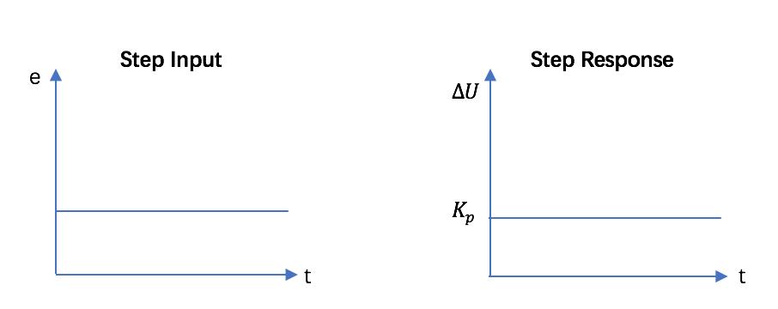

1

Figure 2 the step input and response of P-Controller

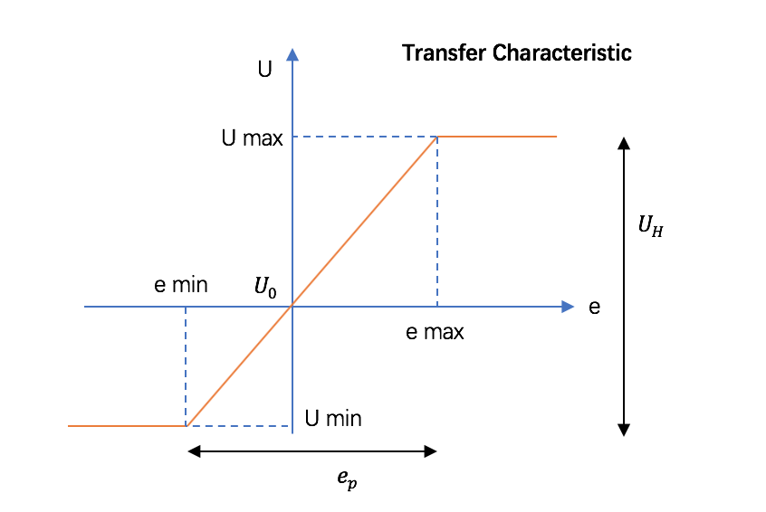

Figure 3 Transfer characteristic of P-Controller

1. **Evaluation**

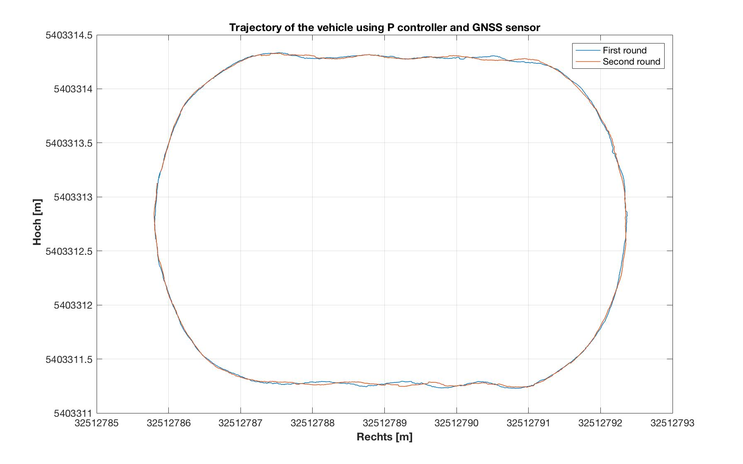

Figure 4 Trajectory of the vehicle using P controller and GNSS sensor

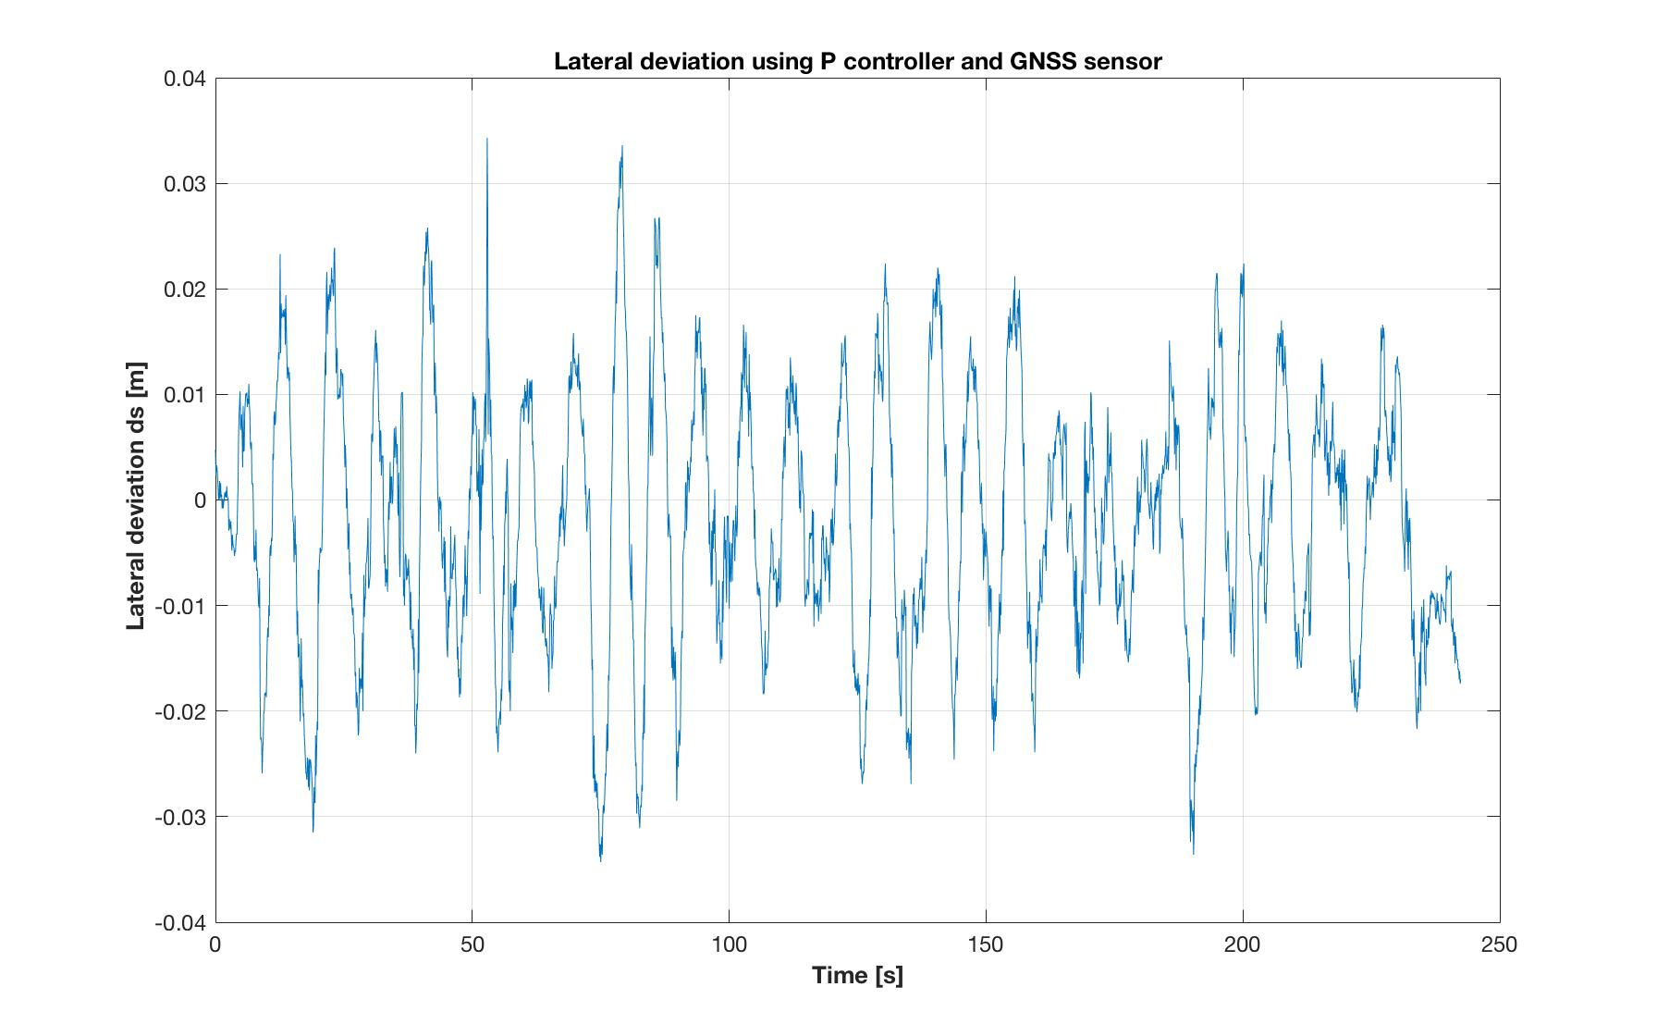

Figure 5 Lateral deviation using P controller and GNSS sensor

The test drive is done on ‘Oval’ reference trajectory with 2 Lines, 4 Clothoids, and 2 curves. The velocity must be almost constant during this test drive.

Figure 4 we can see differences between first and second rounds specially in Lines part, these lead to clear difference in RMS between both rounds. And Figure 5 give us a straight impression how the lateral deviation will change with time, we can see an oscillating around 0, with average amplitude around 10 mm.

The control quality and measurement accuracy can be analyzed by computing RMS of lateral deviation ds(t) or e(t) using following formula:

Where: n number of measurements

lateral deviation

The RMS of first drive could be bigger than second one, due to errors at the beginning of the drive, this measurements could be deleted to have better evaluation, but we didn’t delete it here.

Table 2 Computed RMS of lateral deviation

|  |  |  |  |  |
| --- | --- | --- | --- | --- |
| **Round** | **RMS [m]** | | | |
| **Line** | **Clothoid** | **Curve** | **Total** |
|  | 0.0149 | 0.0145 | 0.0101 | **0.0130** |
|  | 0.0120 | 0.0131 | 0.0104 | **0.0116** |
| **Whole drive** | 0.0135 | 0.0138 | 0.0102 | **0.0124** |

In our test drive the lateral deviation for curve is better than those for straight line and clothoid.

In order to enhance the measuring process many rounds could be driven to have more set of data.